

Java Institute for Advanced Technology
SOFTWARE APPLICATION DESIGN
FINAL VIVA EXAMINATION

G. IMESH DILSHAN PERERA
207978817
200111602407
COLOMBO BRANCH

Software Requirements Specification

for

Vision Communication & Bookshop
Version 1.0

Prepared by
Imesh Dilshan Perera | 200111602407 | imeshdilshan1020@gmail.com |  | 0787181820

Instructor: | Mr. Vishwa Nuwanthika
Course: | Software Engineering
Batch: | Eagles
Teaching Assistant: | Mr. Vishwa Nuwanthika
Date: | 2022.07.31
ContentK.H.Narmada Harishchandras

Table of Contents

Table of Contents 2
Introduction 3
Document Purpose 3
Product Scope 3
Definitions, Acronyms and Abbreviations 4
References and Acknowledgments 4
Overall Description 4
Software Perspective 4
Users and Characteristics 4
Operating Environment 5
Design and Implementation Constraints 5
User Documentation 5
Assumptions and Dependencies 6
Specific Requirements 6
External Interface Requirements 6
User Interfaces 6
Hardware Interfaces 7
Software Interfaces 7
Functional Requirements 7
Other Non-functional Requirements 7
Performance Requirements 7
Logical Database Requirements 8
Safety and Security Requirements 8

Introduction
This Software Requirements Specification (SRS) document provides an overview of the Vision Communication & Bookshop Manager.

Document Purpose
These Software Requirements Specifications (SRS) provide a detailed overview of the requirements for the Bookshop management system for users. Here, you will be given a complete understanding of what to expect from the newly introduced system to be built. Having a clear understanding of the system and its functionality not only allows for the development of the right software, but also contributes to the development of future stages of the project. SRS is the basis for the project. Using this SRS, the Bookshop management system can be designed, built and finally tested. SRS is used by the Bookshop management system end-users and system development team. In order to build the right software, the project team will use SRS to fully understand the prospects of this project. End users will be able to use this SRS as a "test" to see if the construction team builds the system according to their expectations. If the SRS does not match the level expected by the end users, the team will modify the SRS to suit the needs of the end users.

Product Scope
The software product to be discussed here is a Bookshop management system that automates the bookshop's key operations. Several subsystems can be introduced here. They are,
- Product/Products Billing and generate a customer bill report.
- New stock can be added to the system via GRN management and get GRN reports.
- Available Stock View page and generate a report.
- Daily Profit, Monthly Profit, Total Profit and Stocked product value viewing page with reports.
Bookshop Owner is the end user of the Bookshop management system.
He has access to the full system.
The system is able to handle all customers and product buyers quickly.
Especially,
- The system must be user-friendly
- It should be easy to use
- Errors should be easily remedied
- The overall end user should have high subject satisfaction.

Definitions, Acronyms and Abbreviations
- SRS - Software Requirements Specification
- BMS - Bookshop Management System
- End user - User who actually use the system
- Subject Satisfaction - The overall satisfaction of the system

References and Acknowledgments
- https://www.scribd.com/doc/15503906/Book-Shop-Automation-SRS
- https://pdfcoffee.com/book-store-management-system-pdf-free.html
- https://www.studocu.com/row/document/sri-lanka-institute-of-information-technology/software-architecture/srs-document-for-hotel-management-system/8749747

Overall Description

Software Perspective
BMS is an independent system. Also, it is completely self-contained. This gives the system easy access and is user-friendly with an attractive interface. The system handles a database system for better performance, avoiding computational errors, and performing other client-specific tasks. The end result of this project is to increase the efficiency of all the work done in the Bookshop and make the work easier.

Users and Characteristics
This Bookshop Management System has only one user level.

Owner / User :
The Owner / User has the privilege of overseeing and authorizing all the work that the system handles. He has access to everything the system does. He will be able to get all kinds of records and reports in the system. As the Owner / User of the system and the business, he has the power to set product selling rates and update them. User has the sole right to delete any product from the system database and get any product from the system database for his / her personal use.
Other perspectives are,
- Adding new products to the system, modifying or removing them.
- Adding new good receivers to the system, modifying or removing them from the system.
- Add, modify or remove new brands to the system.
- Add, modify or remove new categories to the system.
- Give quick discounts on selected products or sell over the predefined selling value not more than 2*buying price when product billing.
- Update selling prices in products.
- get all reports in the system.

As user features,
- Education level of BMS computer software - High
- Experience in Bookshop Management System Software - None
- Technical expertise - A-bit

Operating Environment
Hardware:-
- The system must be running on a system based on Microsoft Windows.
- 2GB+ RAM, monitor with minimum resolution of 1024x768, keyboard, and mouse.
- Hard Drive should be in NTFS file-system formatted with minimum 5 GB of free space.
- A printer will need to be used to print these reports and notes.

Software:-
- Software is designed to run on any platform above Microsoft Windows 7 (32bit).
- MySQL database management system.
- Java 8 Version

Design and Implementation Constraints
The software developer has put his utmost effort into developing the system. To maintain the reliability and durability of the system, certain design and implementation limitations are also applied. It is recommended that the system have 2GB of memory. When designing system interfaces, the interfaces are designed in a simple and realistic way using affordable technology, taking into account the client's budget.

User Documentation
The user manual is provided to the client to get a clear idea of how the system interacts. It is written in simple understandable language that hides the internal complexity of the system. I will also provide the client with a hard copy of the user manual upon locating the system.

Assumptions and Dependencies
The client agrees to pay for the purchase of any online database services if he needed or the client can use a locally placed MySQL database. Developers are not responsible for the data that is on the database that is locally placed. On behalf of the client, we will create software that can run on the windows operating system, and if you are using another operating system, may need to modify the SRS accordingly.

Specific Requirements

External Interface Requirements

User Interfaces
The user interface of this software is described in the table below.

Screen Name | Description
Splash Screen | Shows the Application loading
Login | Log into the system as a End User
Main Interface | given chances to move with frames that the user needs to move.
Billing Area | Customer billing area. Can be used to bill the product or give some quick discounts. Payment must be more than a product value. else you can’t process the bill.
Bill Report | When the billing is correct, the bill report will be generated.
GRN Area | Accept goods for the Bookshop and system. System shows how much to be paid for the buyer and how much the new bill is valued. The End User can pay at the moment or can pay any other time. It accepted Not Today Paying in use of 0.
GRN Report | When GRN bill correctly accepted, the report will be generated
Stock Area | Users can get knowledge of which products in the shop and search products in many ways and they can update the selling price using this page.
Stock Report | Availability ,Prices and much more details in the shop.
Profit Area | Daily, Monthly ,Total time profit that generated from sales and how much total sell income had got by product by product.
Profit Report | All data that mentioned in the Profit page can be get one single Report here

Hardware Interfaces
The minimum RAM requirement is 2GB and the processor must be compatible with it, which requires a computer to run (Mouse, Keyboard) and no special graphics cards. A monitor aspect ratio must be 4:3 or 16:9. A printer is essential for generating bills. Microphone and speakers are not essential.

Software Interfaces
The system must be running on a system based on Microsoft Windows. It is compatible with all versions of Windows 07 and above. Java JDK 8.0 is compatible. The system is connected to the MySQL database server.

Functional Requirements
Functional Requirements The system defines the basic actions to be performed. We defined thirteen functional requirements for the system. They are,
- Login to the System
- Bill Products
- Give quick discounts when billing
- Generate customer bill
- Add stock by GRN
- Manage buyers payments and received goods.
- Good received confirmation bill
- Manage inventory (add, edit, delete)
- Update selling prices
- Obtain reports (stock, income, profit)
- System Settings (Theme, Login Details, etc..)
- Get immediate database backup

Other Non-functional Requirements

Performance Requirements
Performance requirements define the acceptable response time for a system to operate.

- Loading time for user interface screens does not take more than five seconds.
- If unexpectedly closed some of the non-listed details may be safe. All listed details are safe.
- Inquiries will give results within five to ten seconds. (Less than 1 minute confirmed)

Logical Database Requirements
Logical database requirements include the retention of the following data element. This list is not a complete list and was created as a starting point for development.

Vision Communication and Bookshop System

- Product Name
- Product Quantity
- Product Brands
- Product Category
- Selling Price
- Buying Price
- Billing Date
- Product Stocked Date
- Product Buying From
- Payments For Buyers
- Buyer Mobile Number
- Total Bill Values
- Product Expire Date ( If Available )
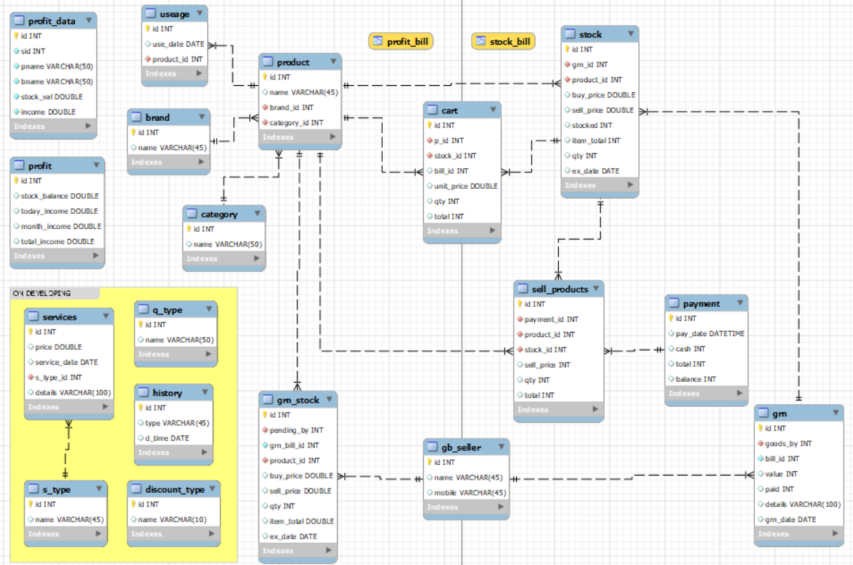
Figure 1: ER Diagram

Safety and Security Requirements
The end user can log in to the bookshop management system. The user can access and experience all features. Settings can be allowed to Change Login Details. Must Use the given Security code for that.
Appendix A - Group Log
This activity was performed alone.

